Increasing Interest and Attendance at the Theatre
Source: Department For Culture Media & Sport
Arts and theatre engagement for adults with an illness or disability that means that they have substantial difficulties with memory or the ability to concentrate, learn or understand
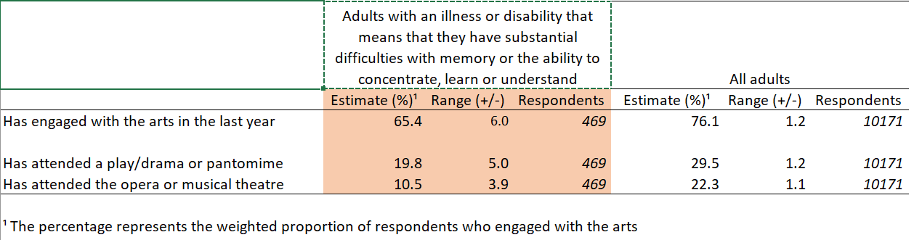

This table shows that more than double the amount of respondents with no illness/disability for concentration/learning/understanding has engaged with the arts and attended more dramas/ musicals. There is more of a range of respondents with illnesses than without.
Considering this data, improvements could be made on website features to tailor them to disabled adults. These could include:
- enlarging font size to make text more readable to users
- keeping contrast sensitivity low in case users have vision impairments
- adding pictures with Alt Text for users with low vision/vision impairments
- using simple vocabulary that is easy to understand for descriptions
- keeping descriptions short and to the point
- spacing out descriptive text to make it more clear(e.g. by using bullet points)

Strong Theatre Sales In London And Rest Of UK
Source: CIC
Hit musicals increased ticket sales to the theatre so theatre audience grew, which increased box office revenue and ticket price.
Following from this information, by advertising hit shows on the main page as the first thing the customer sees peaks their interest and increase chances of them buying that ticket, therefore increasing the business of the website.

